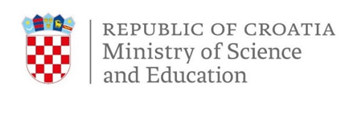
MEDIA PROGRAMME

Informal meeting of ministers responsible for Competitiveness (Research)

Tueseday, 4 February 2020
Zagreb, Croatia

Tuesday, 4 February

7:00 Press centre opens
8:00 - 8:45 Arrival of ministers from hotels to the National and University Library
(Doorstep)
9:15 – 9:45 Opening of the meeting
      - Welcome address by Prof. Blaženka Divjak, Ph. D., Minister of Science and Education (~10 min)
      - Introduction by Mariya Gabriel, European Commissioner for Innovation, Research, Culture, Education and Youth (~20 min)
9:45 – 10:00 Keynote by Mr Philippe Busquin
- Launch of the Future of ERA discussion by ex-Commissioner who launched ERA 20 years ago.
10:00 – 10:15 Keynote by Mr Mate Rimac
- Focus more specifically on brain circulation by one of the most influential innovators and entrepreneurs from Croatia on conditions to keep, attract, gain and retain talents.
10:15 – 12:05 Round table discussion
New European Research Area and Brain circulation
- Conclusion by Mariya Gabriel, European Commissioner for Innovation, Research, Culture, Education and Youth (~ 5 min)
- Conclusion by Prof. Blaženka Divjak, Ph. D., Minister of Science and Education (~5 min)
12:05 – 12:20 Family Photo
12:30 – 14:30 Press conference (live broadcast)
Prof. Blaženka Divjak, Ph. D., Minister of Science and Education
Mariya Gabriel, European Commissioner for Innovation, Research, Culture, Education and Youth

Lunch
14:30 – 15:15 Closing of the meeting (transport to the airport/hotel)

